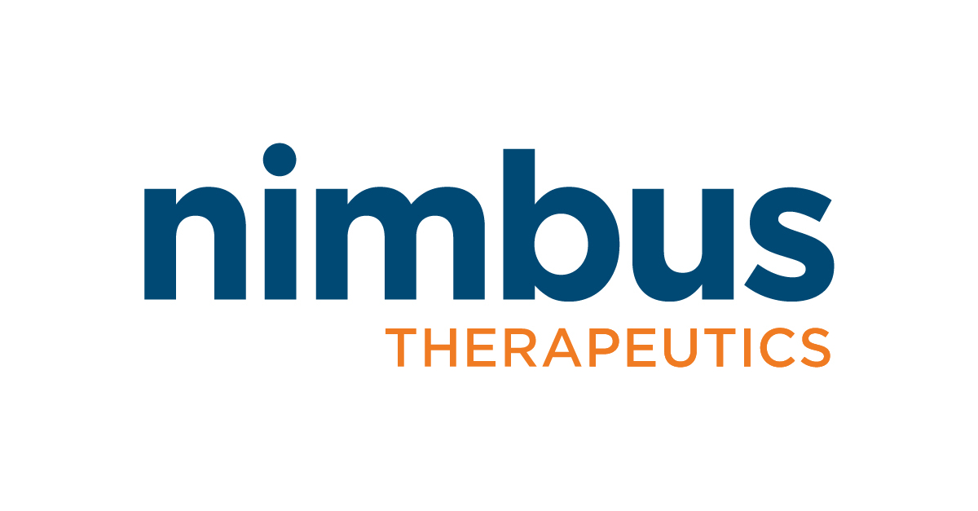

Director / Senior Director, Nonclinical Safety (Toxicology)

Cambridge, MA
Nimbus has an outstanding opportunity for a Director / Senior Director of Nonclinical Safety (Toxicology) to join our rapidly growing team. This role will lead the safety strategy, from discovery through both nonclinical and clinical stages, and direct all phases of early investigative toxicology and in vivo non-GLP and GLP toxicology studies, in collaboration with project teams, CROs and consultants. The person in this role will interface with various functional groups within the company and will report to our Executive Director of Nonclinical Safety.

In This Role, You Will:
- Develop the strategy of nonclinical development plan in collaboration with stakeholders
- Propose and implement project-specific nonclinical toxicology study design (non-GLP and GLP), and ensure execution of toxicology studies to support company timelines and goals
- As a study monitor, direct and oversee nonclinical toxicology studies including but not limited to genetic toxicology, safety pharmacology, general toxicology, and development and reproductive toxicology studies supporting nonclinical and clinical development programs
- Oversee the selection and management of consultants and CROs. Manage nonclinical safety studies conducted by CROs with efficient governance including contract execution, authorization of study amendments, schedule and budget variance management, progress reporting to stakeholders, demonstrate the ability to interpret the data, review draft study reports, completion of contract milestones, study close-out and alignment of nonclinical safety evaluations with drug development efforts and priorities. Ensure compliance with global nonclinical toxicology studies as per regulatory guidelines
- Prepare all nonclinical safety-relevant documents to support regulatory filing including IND, IND annual updates, IB, and DSUR, as well as briefing books for US, EU, Japan, and International regulatory meetings and filings
- Respond with scientifically robust rationale to questions from US FDA, EU, Japan, and other health authorities in support of development programs
- Collaborate with CMC, Program & Portfolio Management, Clinical, and Regulatory Affairs to develop program-specific strategies for appropriate data generation in support of development candidate nomination, IND filing, and clinical development of new small molecule drug entities
- Represent Nonclinical Safety at cross-functional project teams

These Qualifications Will Help This Role Be Successful:
- PhD or DVM in Toxicology/Pathology with 10+ years of toxicology experience in the pharmaceutical and/or biotechnology industry.
- Experience in nonclinical GLP toxicology and safety assessment of Small Molecule Drugs from IND/CTA submission through various clinical development phases. Experience with NDA/MAA submission is plus
- Demonstrate knowledge and full understanding of GLP regulatory requirements and providing responses to the FDA
- Excellent verbal and written communication and organizational skills required with demonstrated success in leading projects and interacting with cross functional teams
- Strong leadership competencies and management experience, including selecting CROs and overseeing the quality of relationships
- Attention to detail quality and compliance
- DABT certification preferred but not required
- Ability to navigate, problem-solve, execute, and lead in a dynamic, fast-paced and evolving environment

A Snapshot of Nimbus

Our Science
At Nimbus, we design breakthrough medicines. Utilizing our powerful structure-based drug discovery engine, we create potent and selective small molecule compounds targeting proteins that are known to be fundamental drivers of pathology in highly prevalent human diseases and which have proven difficult for other drug makers to tackle. With a decade-plus track record of success, we’ve built a world-class team in both computationally driven drug discovery and early clinical development while continuing to move the needle for patients.

Our Culture
Nimbus is a close-knit company (our employees are Nimbi, if you are curious!) that values a fast-paced, entrepreneurial, intellectual-stimulating, and collaborative environment. We live by our Core Values: Integrity, a Passion for Excellence, Teamwork, and Authentic Communication and strive to build a community where we bring out the best in each other professionally and personally.

Our Company
Founded in 2009, Nimbus is a private, growing biotechnology company headquartered in Boston, Massachusetts. Learn more about us by going to www.nimbustx.com

Join Nimbus. We are making a difference and you can too.

At Nimbus, we believe our diversity of backgrounds and experiences strengthens our community and our ability to design breakthrough medicines. We prioritize creating an inclusive, welcoming culture that promotes our core values and encourages every Nimbi to bring their whole selves to their work. Nimbus is proud to be an equal opportunity employer. We value and celebrate all our employees and recognize that our diversity and inclusion are keys to our success. Nimbus is committed to providing equal opportunity for all employees and applicants without regard to race, color, gender, gender identity, sexual orientation, age, religion, national or ethnic origin, disability, protected veteran status or any other basis protected by applicable law. Nimbus does not accept unsolicited resumes from any source other than directly from candidates.

